**Software Engineering II Project- “Wheel of Fortune”**

Logo:

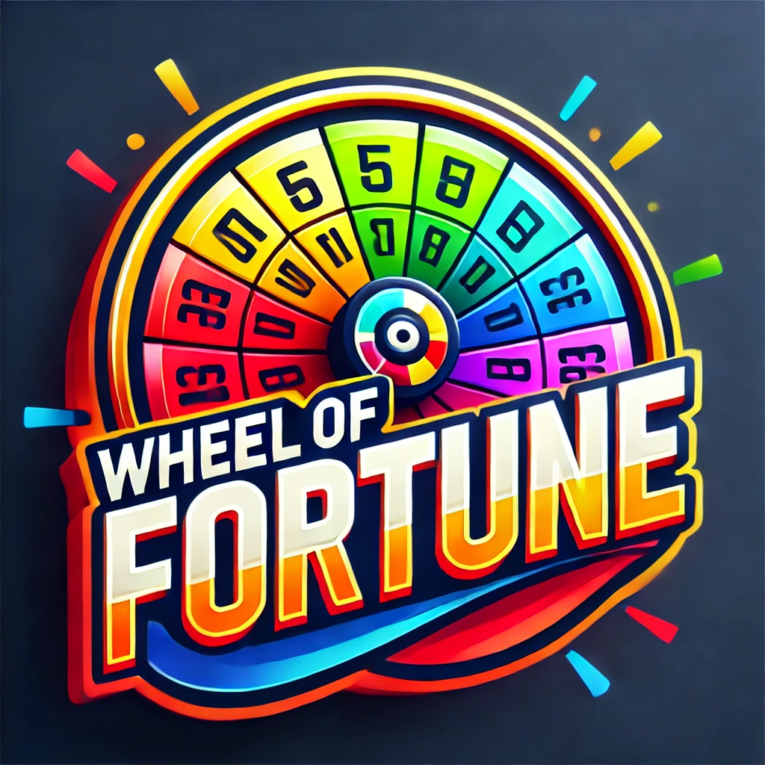

Slogan:

“Spin the Wheel, change your fate!”

Members:

* Alejandro Serrano Ruibal:
  + Alex/Serrano
  + NSWE role: North East
  + MTBI role: Commander
  + GitHub user: alexSerranoR
  + Strengths:
    - Determination and Discipline
    - Versatility and Continuous Learning
  + Areas of growth:
    - Improving Communication in English
  + Interesting fact: the best pichichi striker for your football team, I love fighting (3 years of boxing and muay-thai). Passionate about the stock market, investments and money.



* Eva Sierra Sánchez
  + Eva
  + NSWE role: South
  + MBTI role: Executive
  + GitHub user: evasierrasanchez
  + Strengths:
    - Organised
    - Sincerity
  + Areas of growth:
    - Indecisiveness
    - Patience
  + Interesting fact: I have been competing in roller skating for over 10 years. I love cocking.

* Adrián Cervantes Menéndez 
  + Adri
  + NSWE role: North
  + MTBI role: Commander
  + GitHub user: adricervantesm
  + Strengths:
    - Good listener
    - Leadership
  + Areas of growth:
    - Procrastination
  + Interesting fact: Black belt in judo and former football player



* Bogdan Shchepnny Ivanyshyn
  + Bug
  + NSWE role: South East
  + MTBI role: Executive
  + GitHub user: Bogdan-sy
  + Strengths:
    - Self-Disciplined
    - Results-Oriented
    - Practical Solutions
  + Areas of growth:
    - Resisting Change
    - Overly Critical
    - Neglecting Emotional Needs
  + Interesting fact: I played water polo for 6 years



* Gonzalo Fdez.-Martos Romera
  + Goncho
  + NSWE role: West
  + MTBI role: Entertainer
  + Github user: gonchalo93fmr
  + Strengths:
    - Building Connection
    - Quick Problem-Solving
  + Areas of growth:
    - Impulsive Decisions
    - Prone to Procrastination
  + Interesting fact: I've studied abroad for one year.

Project definition

Videogame version of the TV show Wheel of fortune.

The game will let you feel as if you were one of the contestants with the same excitement, let alone the fun you will have with your family and friends.

The target audience is all public.

Organization

**WhatsApp group:** <https://chat.whatsapp.com/I85ZSqhg8qMCt560tz7ahp>

- To address procrastination, we will set internal deadlines before official ones to ensure progress. Also decision-making will be balanced by discussing options as a group before finalizing.

- Team building activity: We did a “Two truths and a lie” activity to get to know each other better.

Optional

- Group vision: to create an engaging, well-designed Wheel of Fortune game while improving our teamwork and technical skills.

- Project definition: a digital version of Wheel of Fortune that offers an interactive experience for players of all ages.

- Work process: weekly meetings on Discord, task assignments via GitHub and a shared Google Drive for documentation.

- Strengthening the group: we will have a quick debrief at the end of each meeting to address any issues and keep running things smoothly.